## Overview

The purpose of this project is to check the validation of the data by the specific group of people. To do this problem, we are going to use hyperledger fabric for permissioned check.

Also, manipulating report logs of gas overflow in the blockchain should be the another purpose of this project.

## Network Architecture

* ***Organization and consortiums***

**Data Provider**: Organization of providing data handling logs and gas overflow report

**User:** Organization to verify the data validation

**Government:** Organization to retrieve the gas overflow report

* ***Peers, orderers and channels, chaincode structure***

There will be 2 **channels** for segregating communication:

**Data Channel**

* Purpose: To store and retrieve the handling logs of the IoT data
* Participants: Data Provider, Data Handler
* Chaincode: To handle data access control and permissions
  + saveData(data_id, user, status)
  + checkData(data_id, user, filter)

**Alert Channel**

* Purpose: To report a gas overflow event
* Participants: Data Provider, Government
* Chaincode
  + alertData(report_id, timestamp, reported_value)
  + checkData(report_id)

Number of peers of each organization is more than one.

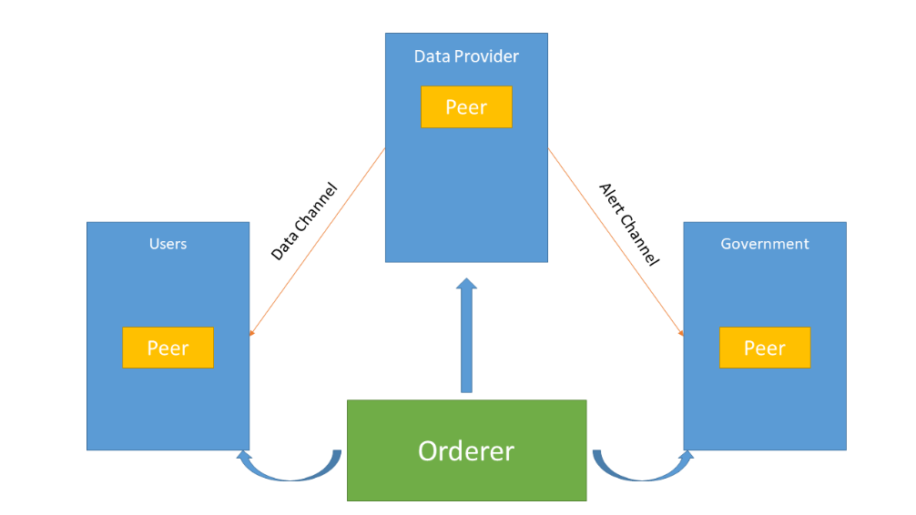

## System Diagram

* ***Interaction with Backend***

Use Fabric SDK for Node.js to interact with Blockchain

* ***Flows and interactions with the blockchain***

This diagram shows the flow of Application based on Hyperledger Fabric

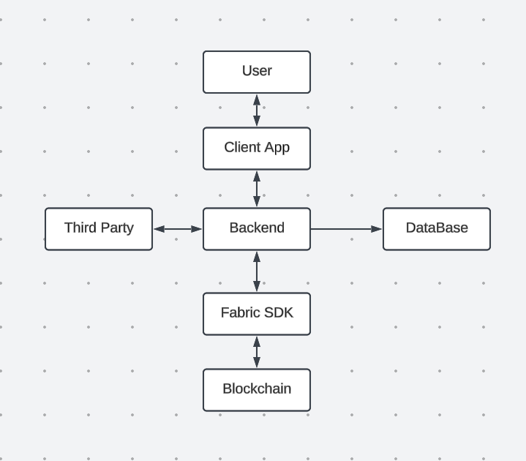

## Milestones

* ***Network Construction(1 week)***

Make Docker container for CA server, peer, orderer, client

* ***Chaincode Deployment(1 week)***

Write chaincode for rule of the network(determine the argument of the functions with server manager)

* ***Network Deployment(1 week)***

Deploy the network on the server

* ***Test the Network(1 week)***

Interact with backend part